**Coaching Registration Process Guide**

After completing the registration process on the [Golden Eagle](https://goldeneagleyouthtr.wixsite.com/golden-eagle-youth-t) website, and using a valid email address, the new coach should now check their email for a message from SSSF and a subject line of SSSF Team Invitation. The new coach must click the blue Complete Registration button to complete their profile. Occasionally the email from ‘SSSF’ will go to the recipients’ spam/junk folder. 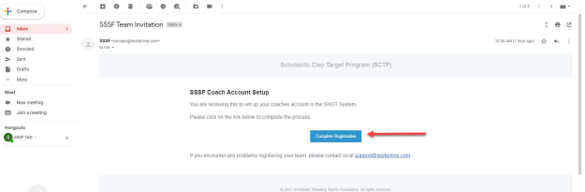

The new coach will be taken to a screen to complete their profile. Once all details are complete, click the green Create Account button.

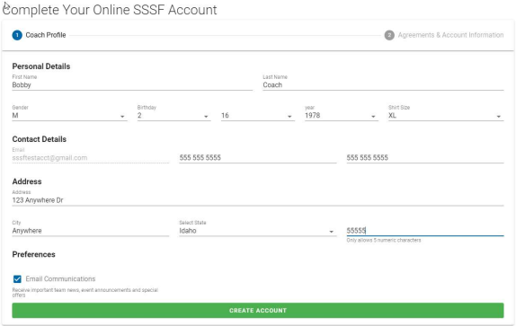

Next, the new coach will setup their personal account by creating a username, pin, password and by acknowledging and signing. Once finished they should click the green Complete Registration button. 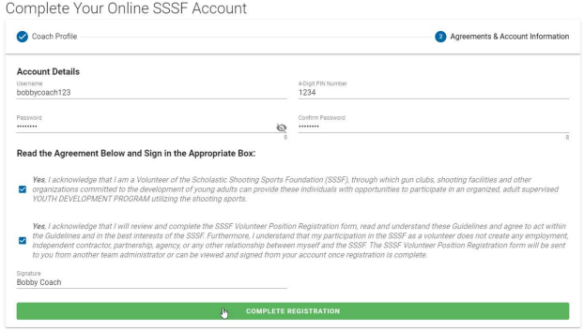

Clicking the Complete Registration button will bring the new coach to their account and access to the team details if they were setup as a team admin. 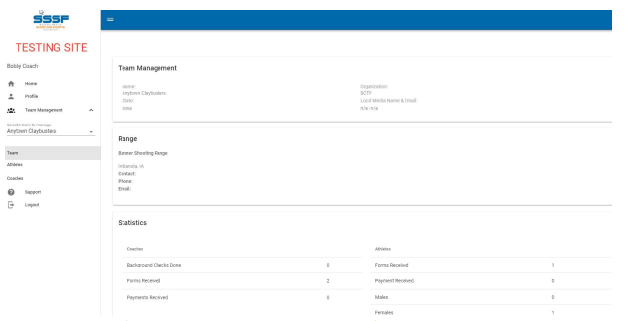

New coaches can self-complete their annual volunteer consent form at this point by going to the registration tab in their profile page and clicking the green Send Registration Email to receive the DocuSign form. Another team admin may also initiate this process as outlined below if necessary.

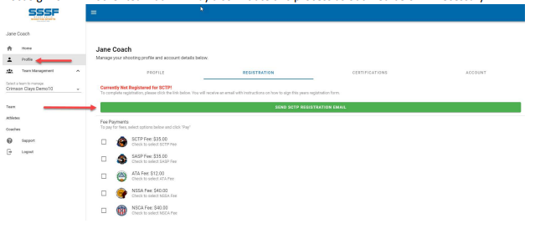

Once the new coach has completed their account, other team admins will see the account has been populated and the annual volunteer consent form can be sent via DocuSign by clicking the link in the red box if the coach has not already self-administered the form.

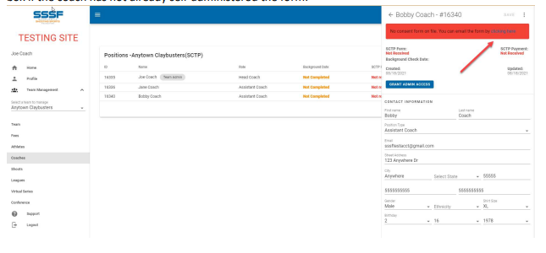

Click the link in the red box and verify the email address is correct. If so, click the green button to Send Signature Request, otherwise edit the email address.

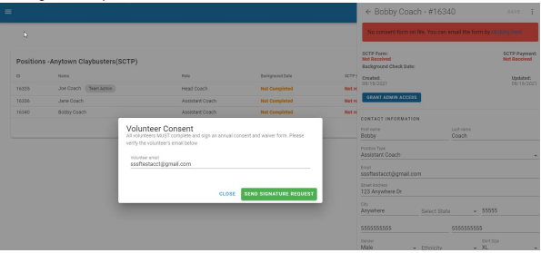

Once the request has been sent, the red box will turn yellow and will verify where the request for signature has been sent. You can resend the form by clicking the link in the yellow box.

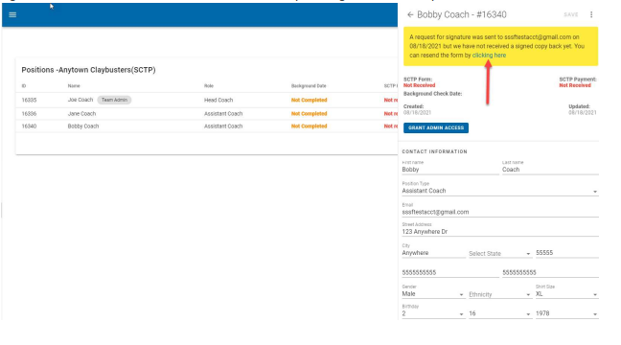

The coach should now check their email and should find a new message from SSSF Registration with a subject about DocuSigning their volunteer form.

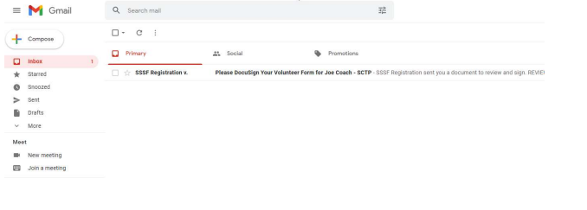

Click Review Document to begin

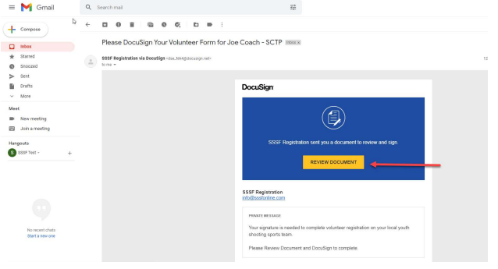

Agree to electronic records and signatures

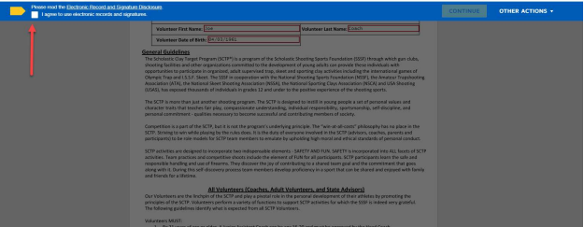

Click Continue

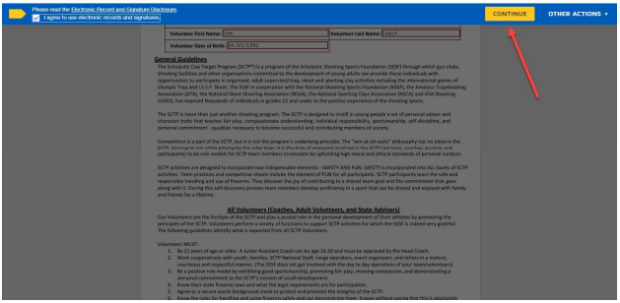

Read the entire document then click the Sign button

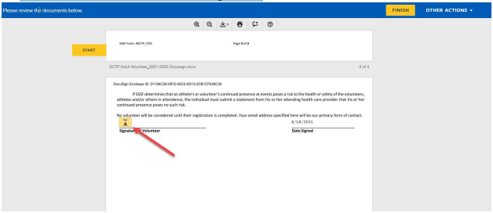

Review name and signature then click Adopt and Sign

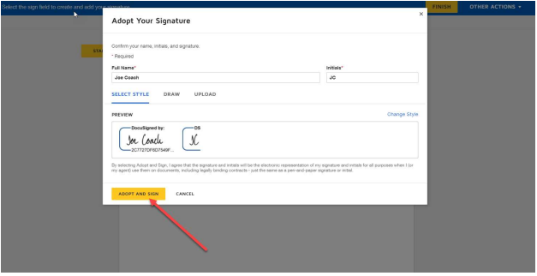

Click Finish

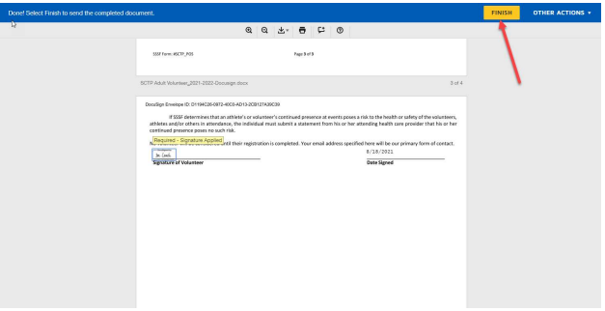

Click Continue and close the browser

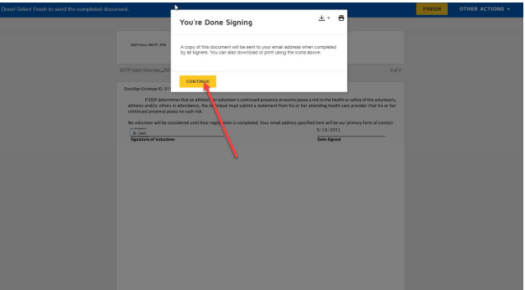

Coaches will receive a copy of their signed form as an email

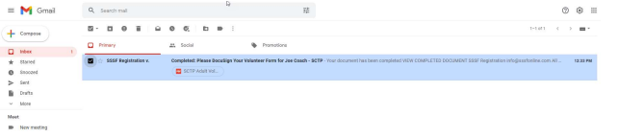

Once signing is complete, other team admins will see the date reflected in the team account

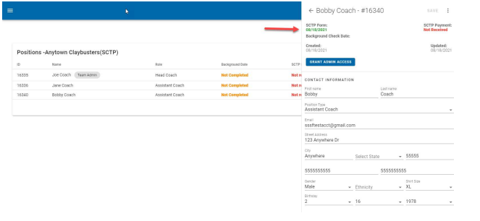

Admin priveleges to the team account can also be granted or revoked at this point by other team admins.